Introduction
The construction industry plays a vital role in the European Union's economy, contributing significantly to its growth and development. Here are key statistics and data highlighting the importance of the construction sector in the EU:
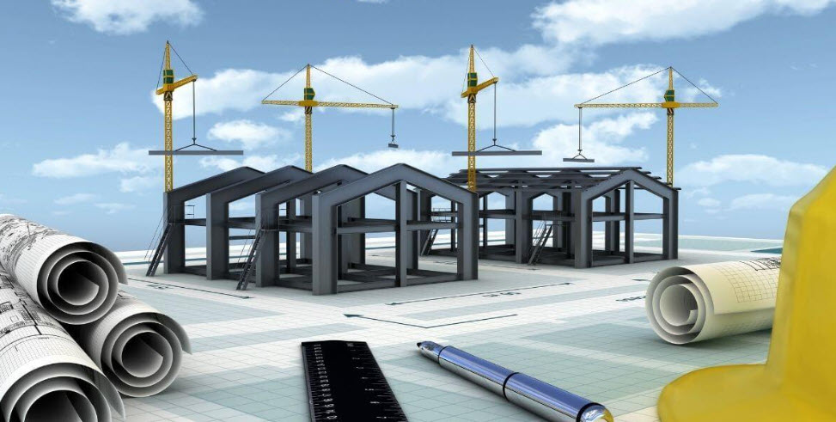

Economic Impact
The construction sector is a major contributor to the EU's economy:
- It generates about 9% of the EU's GDP (EBC, n.d.) (European Commission, n.d.).
- Construction is a significant source of employment in the EU. The sector provides 18 million direct jobs (European Commission, n.d.).
- The EU construction sector is characterized by a large number of small enterprises. There are more than 3 million enterprises in the construction sector (EBC, n.d.).
The construction sector in the EU is divided into three main activities:
- Specialised construction activities account for 59.0% of construction value added and 63.3% of employment (Construction, n.d.).
- Construction of buildings contributes 26.8% to the sector's value added3 (Construction, n.d.).
- Civil engineering makes up 14.2% of the construction total3 (Construction, n.d.).
The construction sector has faced challenges but shows signs of potential recovery:
- In 2023, the EU construction sector contracted by 2.3% (FIEC, n.d.).
- For 2024, a small decline in production volumes (-0.5%) is expected7 (Sante, 2024).
- A marginal increase of 0.5% in total EU construction volumes is projected for 2025 (Sante, ING, 2025).
Subsector Performance
Different subsectors within construction show varying trends:
The renovation subsector, including sustainability works, is experiencing structural growth in demand (Sante, ING, 2024).
Investments in infrastructure are expected to continue growing, driven by EU Recovery funds, digital infrastructure, and energy transition projects (Sante, ING, 2024).

Industry Analysis
Six key players in the construction industry in the Netherlands:
Company | Primary Activities | Recent Innovations | Country of Origin
BAM Group N.V. | - Construction and property development  - Civil engineering  - Public-private partnerships | - Opened a production facility for sustainable wooden Flow homes.  - Developed hydrogen as an alternative to diesel on construction sites (Element One project).  - Focused on energy transition and rail infrastructure markets (MarketScreener, 2025) | Netherlands
Arcadis N.V. | - Architecture and engineering design  - Construction consultancy | - Implemented AI and data analytics for asset optimization.  - Expanded technology-enabled solutions for the asset lifecycle.  - Enhanced digital product offerings for efficiency savings (arcadis, 2023) | Netherlands
Aalberts N.V. | - Manufacturing mission-critical technologies  - Surface and heat treatments | - Invested in electrically powered multifunctional furnaces.  - Developed mechatronic systems for high-end machines.  - Focused on ultra-high purity liquid and gas supply systems for semiconductors (Aalberts, n.d.) | Netherlands
Heijmans N.V. | - Property development  - Residential and non-residential building  - Infrastructure development | - Adopted modular construction techniques.  - Reduced CO2 emissions by 30% (2024 vs. 2023) and aims for climate neutrality by 2040.  - Experimenting with rainwater reuse and energy management systems.  - Launched the BioBuddy biodiversity monitoring box.  - Improved safety strategies, reducing incident severity and frequency rates (heijmans, 2025) | Netherlands
Cementir Holding N.V. | - Cement production  - Ready-mixed concrete manufacturing  - Aggregates processing  - Waste management | - Introduced FUTURECEM™ technology, reducing CO2 emissions by 30%.  - Expanded FUTURECEM™ to France and Benelux.  - Developed Ultra-High-Performance Concrete (UHPC) products.  - Implemented Cementir 4.0 digitalization project.  - Committed to a 30% CO2 reduction by 2030 with €107 million in sustainability projects.  - Collaborated on CALLISTE research for further CO2 reductions (cementirholding, 2023) | Italy
SIF Holding | - Offshore wind turbine monopile manufacturing  - Transition pieces and pin-piles | - Built the world’s largest monopile manufacturing plant in Rotterdam (€328 million investment).  - Increased production capacity to 500 kilotons/year.  - Developed XXXL monopiles (up to 11.5m diameter, 2,500 tons).  - Improved sustainability through electrification of production processes.  - Innovated technologies like Skybox for TP-Less foundations and green steel transition.  - Produced first monopile at expanded Maasvlakte II plant in late 2024 (Sif, n.d.) | Netherlands
Table 1: Six key industry players

BAM Group N.V.
Primary Activities:
- Construction and property development
- Civil engineering
- Public-private partnerships
Recent Innovations:
- Opening of a production facility for sustainable wooden Flow homes concept.
- Development of hydrogen as an alternative to diesel on construction sites through the 'Element One' project.
- Focus on energy transition and rail infrastructure markets (MarketScreener, 2025).

Arcadis N.V.
Primary Activities:
- Architecture and engineering design
- Construction consultancy
Recent Innovations:
- Implementation of AI and data analytics to help clients repurpose and improve assets.
- Development of technology-enabled solutions across the entire asset lifecycle.
- Expansion of digital products offering for asset optimization and efficiency savings (arcadis, 2023).

Aalberts N.V.
Primary Activities:
- Manufacturing of mission-critical technologies
- Surface treatments and heat treatments
Recent Innovations:
- Investment in electrically powered multifunctional furnaces for surface technologies.
- Development of mechatronic systems and motion and fluid control for high-end machines.
- Focus on ultra-high purity liquid and gas supply systems for the semiconductor industry (Aalberts, n.d.).

Heijmans N.V.
Heijmans NV is a major Dutch construction company with a focus on creating healthy living environments.
Primary activities:
- Property development
- Residential building
- Non-residential building
- Infrastructure development
Recent innovations:
- Modular construction: Heijmans is implementing prefabrication techniques for finishing and technical installations in data center projects, improving efficiency and reducing on-site construction time (heijmans, 2025).
- Sustainability initiatives: The company aims to make its operations and supply chain climate-neutral by 2040. In 2024, they reduced Scope 1 and 2 CO2e emissions by 30% compared to 2023.
- Water management: Heijmans is experimenting with rainwater reuse in residential construction sites to reduce household water consumption.
- Energy solutions: The company is testing an energy management system in the Waterviolier district of Nuenen to optimize locally generated energy use.
- Safety improvements: Heijmans has implemented a new safety strategy focusing on High-Risk Activities (HRA), resulting in a decrease in the severity of incidents and a reduction in the Incident Frequency (IF) rate from 3.1 to 2.3.
- Biodiversity monitoring: Heijmans launched the BioBuddy, an innovative biodiversity monitoring box.
Heijmans reported strong financial performance in 2024 and has a positive outlook for 2025, expecting revenue to increase to €2.75 billion and a minimum underlying EBITDA margin of 8.0% (MarketScreener, 2025).

Cementir Holding N.V.
Cementir Holding N.V. is a multinational company operating in the building materials sector, with a focus on cement production and related activities.
Primary Activities:
- Cement production (grey and white cement)
- Ready-mixed concrete manufacturing
- Aggregates extraction and processing
- Waste management and alternative fuel production
Recent Innovations:
- FUTURECEM™ Technology: A patented cement technology that allows for more than 35% clinker substitution with limestone and calcined clay, reducing CO2 emissions by up to 30% compared to ordinary Portland cement (cementirholding, 2023).
- Expansion of FUTURECEM™: Launched in France and Benelux markets in 2022, following its introduction in Denmark in 2021 (cementirholding, 2023).
- InWhite® Solutions: Development of Ultra-High-Performance Concrete (UHPC) products using FUTURECEM™ technology, including Aalborg Extreme® and Aalborg Excel® (cementirholding, 2023).
- Cementir 4.0 Project: Implementation of digital technology throughout the production process to enhance operational excellence and reduce environmental impact (worldcement, 2022).
- Sustainability Initiatives: Commitment to reduce CO2 emissions by 30% by 2030, with a €107 million investment plan in sustainability projects.
- CALLISTE Research Initiative: Collaboration with the Danish Technological Institute to further develop FUTURECEM™ technology, aiming for a 50% CO2 reduction compared to conventional Portland cement by the end of 2024.
- Product Innovation: Development of high added-value and technologically advanced white cement-based solutions through the Aalborg InWhite Solution™ platform (cementirholding, n.d.).
These innovations demonstrate Cementir's focus on sustainability, digitalization, and product development to maintain its position as a leader in the cement industry, particularly in the white cement segment.

SIF Holding
SIF Holding is a leading manufacturer of monopile foundations for the offshore wind energy industry.
Primary Activities:
- Manufacturing of monopile foundations for offshore wind turbines
- Production of transition pieces and pin-piles/jacket legs
- Providing solutions for the offshore wind energy sector
Recent Innovations:
- Construction of World's Largest Monopile Manufacturing Plant: In February 2023, SIF announced a €328 million investment to build the world's largest monopile foundation manufacturing plant in Rotterdam, Netherlands.
- Increased Production Capacity: The new facility at Maasvlakte II in Rotterdam has significantly increased SIF's total combined capacity to 500 kilotons a year.
- XXXL Monopile Production: The upgraded manufacturing plant enables SIF to produce 200 XXXL monopiles annually, with diameters up to 11.5 meters and weighing up to 2,500 tons each.
- Sustainability Improvements: The new facility features higher electrification of production and transport equipment, resulting in lower nitrogen emission and deposition levels compared to previous operational standards.
- Advanced Manufacturing Technology: SIF has implemented next-level integrated manufacturing technology with improved process and quality controls.
- Product Innovation: The company is developing technologies such as the Skybox, which accelerates the installation of TP-Less foundations and simplifies monopiles.
- Research and Development: SIF is working on various innovations including low-noise pile-driving, alternative fixed seabed foundations for deeper waters, and the transition to green steel.
- First Monopile Production: In late 2024, SIF successfully manufactured the first monopile at its expanded Maasvlakte II plant, marking a significant milestone in its innovation journey (EGERIA, 2023).
These innovations have positioned SIF Holding as a critical supplier in the offshore wind value chain, with a strong focus on meeting the growing demand for larger capacity turbines and next-generation 3XL monopile foundations (Sif, n.d.).

Market Capitalization
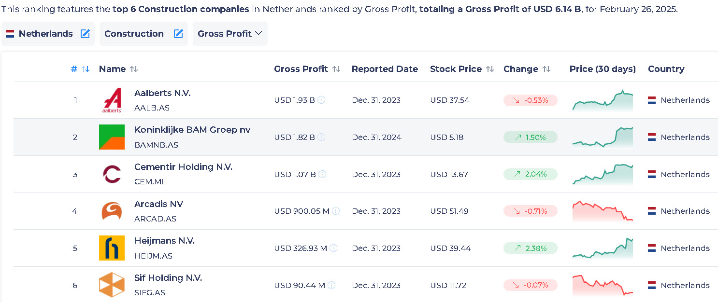
Image1: Market Capitalization (StockViz, 2025)

Revenue
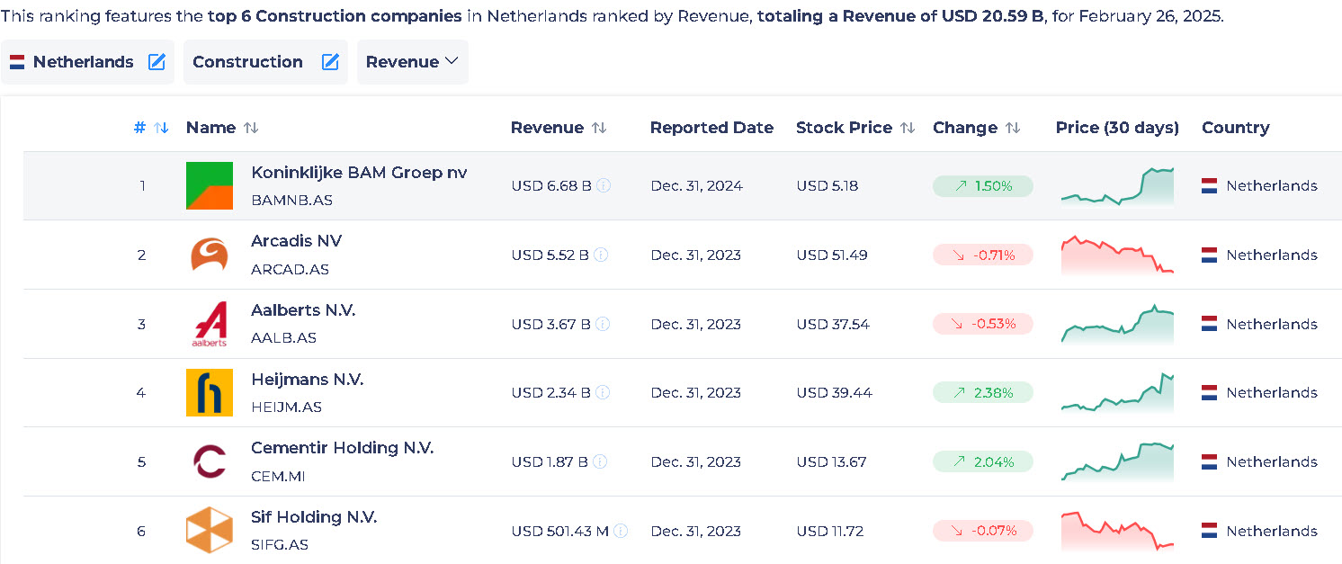
Image2: Revenue (StockViz, 2025)

The Biggest challenges in the mentioned companies

Company | Biggest Challenges
BAM Group N.V. | - Attracting and retaining skilled employees.  - Uncertainty regarding interest rates, Dutch nitrogen regulations, and political unrest.  - Supply chain issues and project delays in construction markets, particularly in the UK (BAM, 2025)
Arcadis N.V. | - Rising costs of implementing digital and AI technologies.  - Managing workforce transitions to adopt new technology.  - Balancing sustainability goals with client demands for cost efficiency (arcadis, 2023)
Aalberts N.V. | - Skilled labor shortages, particularly engineers, impacting innovation.  - High raw material costs and inflation affecting profitability.  - Low productivity growth in European machinery markets (Aalberts, 2025)
Heijmans N.V. | - Regulatory challenges with stricter sustainability standards.  - Rising material costs due to inflation.  - Delays in project completions caused by supply chain disruptions.  - High costs of transitioning to emission-free construction (heijmans.nl, n.d.)
Cementir Holding N.V. | - High investment requirements for sustainability projects (e.g., FUTURECEM™ expansion).  - Balancing CO2 reduction targets with operational efficiency.  - Competition in the cement market for low-emission products (cementirholding, 2023)
SIF Holding | - Managing high capital investments (€328 million) for new facilities.  - Transitioning to green steel and low-noise pile-driving technologies.  - Adapting to stricter sustainability regulations while maintaining profitability (Sif, n.d.)

The biggest challenges in Royal BAM Group N.V. :
Sustainability: The company has set ambitious goals to build a sustainable tomorrow, which requires transforming their products and services to become more digital, scalable, and environmentally conscious13. This transition from conventional (grey) to environmentally conscious (green) construction practices is a major challenge (bam, n.d.).

The biggest challenges in Arcadis N.V.:
Geopolitical uncertainty: The company is experiencing increased volatility due to geopolitical uncertainty following a high number of elections in 2024, which is affecting short-term spending patterns (ARCADIS, 2025).

The biggest challenges in Heijmans N.V.:
CO2 emissions reduction: Aalberts has been working to reduce its carbon footprint, having decreased annual scope 1 and 2 emissions by 30% since 20173. However, the company still lags behind peers in environmental transparency and needs to prioritize reducing emissions further (CFA institite, n.d.).

The biggest challenges in Aalberts N.V.:

Neuroject. (2024, December 11). Top 7 Construction Company in Netherlands. https://neuroject.com/construction-company-in-netherlands/
StockViz. (2025, February 17). Top Construction companies in Netherlands by Gross Profit. https://stockviz.com/en/ranking-of-netherlands-stocks-in-construction-by-gross-profit
AeroLeads. (2023, April 28). List of Construction Companies In Netherlands In 2025. https://aeroleads.com/list/top-construction-companies-in-netherlands
Statista. (2023). Netherlands' top construction firms revenue 2023. https://www.statista.com/statistics/968572/largest-construction-companies-based-on-revenue-in-the-netherlands/

